Relational Databases with MySQL Week 4 Coding Assignment

**Points possible:** 70

|  |  |  |
| --- | --- | --- |
| Category | Criteria | % of Grade |
| Functionality | Does the code work? | 25 |
| Organization | Is the code clean and organized? Proper use of white space, syntax, and consistency are utilized. Names and comments are concise and clear. | 25 |
| Creativity | Student solved the problems presented in the assignment using creativity and out of the box thinking. | 25 |
| Completeness | All requirements of the assignment are complete. | 25 |

**Instructions:** Using a text editor of your choice, write the queries that accomplishes the objectives listed below. Take screenshots of the queries and results and paste them in this document where instructed below. Create a new repository on GitHub for this week’s assignments and push this document, with your Java project code, to the repository. Add the URL for this week’s repository to this document where instructed and submit this document to your instructor when complete.

**Coding Steps:**

Write 5 stored procedures for the employees database.

Write a description of what each stored procedure does and how to use it.

Procedures should use constructs you learned about from your research assignment and be more than just queries.

1. **GetCountByJobTitle**

This stored procedure takes in a job title as a parameter. The SQL statement counts the number of employees with the job title from the titles table. Then, it returns the total number of employees from the titles table that have that job title.

1. **HighlyCompensatedEMployee**

This stored procedure identifies if an employee is highly compensated or not highly compensated. It passes in the employee’s first and last name from the employee info table. Then, it identifies the salary of the employee. If the salary is greater than $80,000 the employee is highly compensated. If not, they are identified as not highly compensated.

1. **GetCountBySalary**

This stored procedure returns the number of employees with a certain salary. It passes in a salary amount from the salaries table and counts the number of times that salary appears. Then, the count is returned.

1. **CountNumberOfSalaries**

This stored procedure passes in a salary amount as an argument. Then, it looks in the salaries table to identify the number of salaries of that amount but it only counts when the salary amount is less than or equal to $100,000.

1. **DepartmentSize**

This stored procedure passes in a department number as an argument so that the size of the department can be determined. It looks at the dept_no table to count the number of employees in each department. Then, it categorizes the size of the department based on the number of employees so it is identified as small, medium or large.

**Screenshots:**

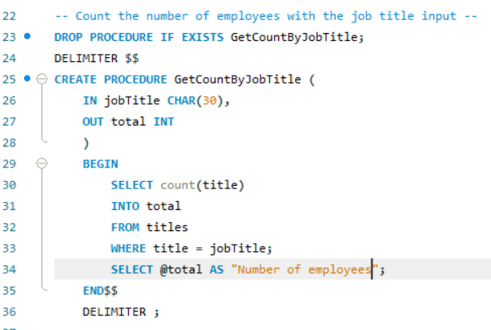

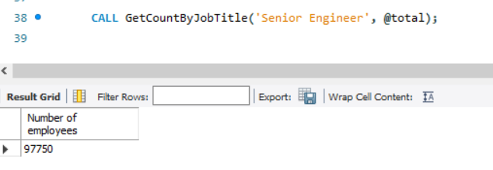

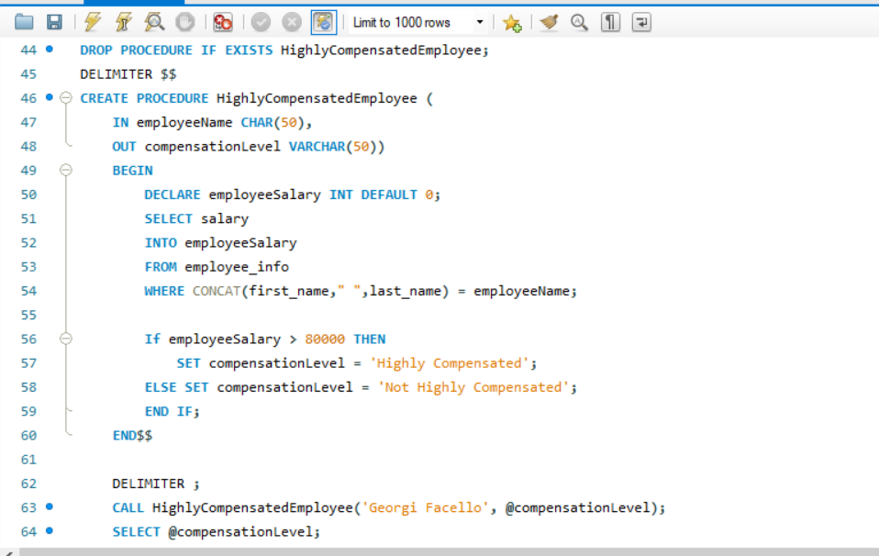

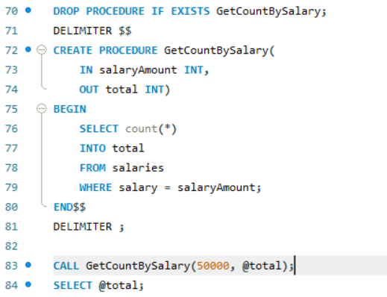

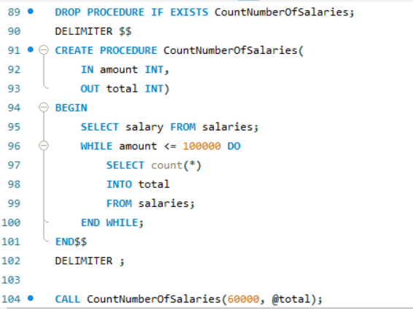



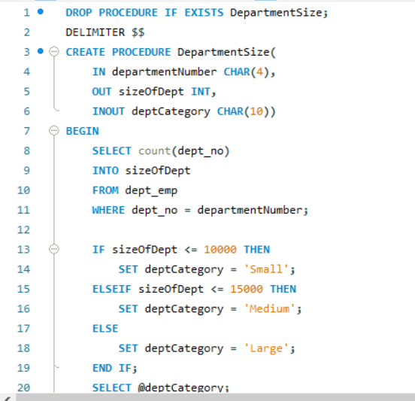

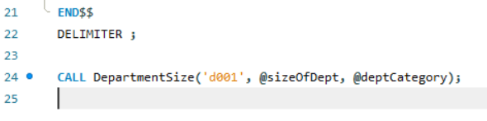

**URL to GitHub Repository:**

[**https://github.com/azshjones12/Week-4-SQL-Coding-Assignment.git**](https://github.com/azshjones12/Week-4-SQL-Coding-Assignment.git)